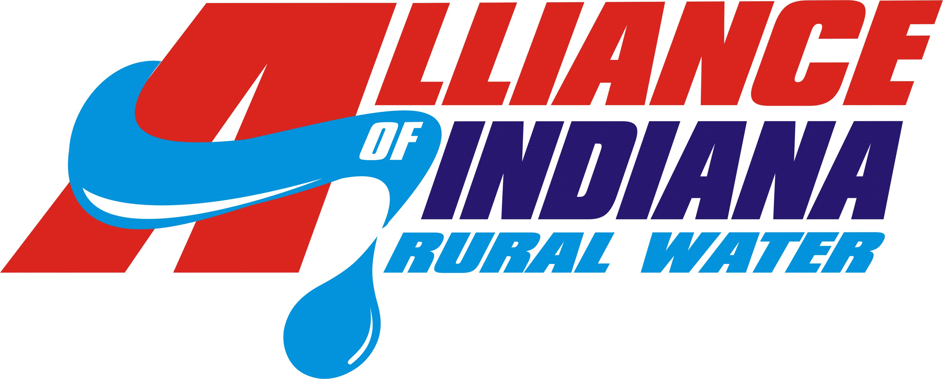
Scholarship Application
(Please Print or Type)

A. Personal Information

Name: (Last) (First) (MI)

Address:

City: State: Zip:

Phone: Email:

B. Member Information (Applicant must be a dependent child of a system employee of a water or wastewater voting utility.)

Utility Name:

Employee Name:
Applicant’s relationship to employee: _____________________________________________________________

C. High School Information (Applicant must be a high school graduate or equivalent. Application needs to be submitted within one year of graduation or certification. Transcripts must submitted with application.)

School Name: Graduation Date:

Address: City: State: Zip:

GPA: SAT Score (total): Class Rank: out of:

Attach a typed list of school and community activities, awards and honors, and other special recognition you have received during the last four (4) years

D. Work Experience – (Describe any work experience during the last four (4) years.)

____________________________________________________________________________________________
____________________________________________________________________________________________
E. College / University Information (Application needs to be submitted within one year of high school graduation or certification.)

School Name:

Address: City: State: Zip:

Please indicate: ______ 4 Year College/University
Vocational/Technical School
2-Year Community/Junior College
Other, Specify:

Major Course of study:
(Priority will be given but is not limited to water/wastewater related studies)

F. Financial Information
Please indicate which of the following income ranges matches your gross family income:
Under $30,000 $30,000 - $50,000 $50,000 - $70,000 Over $70,000
If you are receiving other known financial aid/scholarships, please itemize by name and amount.
Name: Amount:
Name: Amount:
Name: Amount:
If there are any family circumstances that influence your need for financial assistance, please describe:

G. Essay
On a separate page in 250 words or less. (Please type)
Write a brief essay on your goals as they relate to your education, career, and future plans.

H. Certification
In submitting this application, I certify that the information provided is complete and accurate to the best of my knowledge. False information will result in revocation of any scholarship granted.

Applicant's Signature: Date:

Parent's/Guardian’s Signature: Date:

OFFICIAL RULES
This scholarship will be made to defray the cost of educational expenses at an accredited institution of higher learning approved by the Alliance of Indiana Rural Water. Disbursement of the money will be made upon presentation of proof of enrollment (transcript or invoice.) Scholarship money will be paid directly to the scholarship winner. Application needs to be submitted within one year of high school graduation or certification, and applicant must be a first-year college student enrollee. In addition, applicant cannot have received a prior scholarship from the Alliance of Indiana Rural Water. Applicant must be a citizen or legal resident of the United States, a resident of the state of Indiana and a dependent child of a SYSTEM EMPLOYEE of a water or wastewater voting utility (Utility Board members’ dependents are not eligible). In order to be eligible, applicant must complete the application form in its entirety and return it to the Alliance by the entry postmark deadline, January 10, 2025. Scholarship recipients will be selected based on the number, length of commitment and quality of leadership in school and community activities, awards, honors, academic records, career goals, work experience and financial need. Application must be signed by both applicant and parent/guardian before submission. Applicants will be evaluated on a comparative basis at the sole discretion of the committee. All decisions are final. Application materials and decisions of the committee shall be confidential. Acceptance of scholarship constitutes permission to use recipient's name and/or likeness for purpose of promotion. No transfer of scholarship is permitted. Applicant must plan to attend an accredited school in the fall of 2025. Recipients will be notified by email. Family members of employees of the Alliance of Indiana Rural Water and/or members of the Board of Directors are not eligible.

Mail application, transcript(s), & essay to: Alliance of Indiana Rural Water
(must be postmarked by January 10, 2025) P.O. Box 789
CHECKLIST
- Completed application
- Essay
- Academic transcript
- School & community activities
- Awards & honors
- Certification signatures

Franklin, IN 46131
OR Email application, transcript(s), & essay to: alliance@inh2o.org
(must be received by January 10, 2025)

